# Project proposal

|  |  |  |  |  |
| --- | --- | --- | --- | --- |
| **Name of Candidates** | **A** | **B** | **C** | **D** |
| **PS Numbers** |  |  |  |  |
| **Name of Mentor – Delivery** | **Hari Balan** | | **PS No 954640** | |
| **Name of Mentor- GEA** | **YYYY** | | **PS No xxxx** | |
| **Project Period** | **From: November 2020 To: December 2020** | | | |
| **Date of Completion** |  | | | |

### **Project Title**

* Linx Printer Pump VAVE Project

### **Project DETAILS:**

1. **aim**:

* Cost reduction through VAVE approach

1. **Problem statement:**

* Present Pump Cost is high

1. **Objectives & Learning outcomes of the project**

* To Reduce the Pump cost
* To Design the New Child Driver board
* To Buy the Printer Pump without Driver board from Pump Manufacturer

1. **Key Deliverables:**

* Driver Board Mounting Design
* Pump Hydraulic Fittings Design
* Pump Mounting design
* Cable Routing

1. **Hardware & Software Recommendations**

* Driver Board Design
* New Cable with Connector

1. **Weekly Progress (gantt chart)**

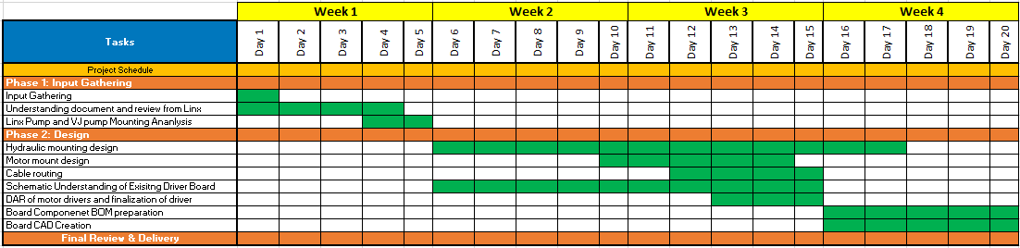

### **REVIEW**

* Weekly reviews to be conducted over the entire tenure of Project
* Each review comprises of a progress presentation from the candidates
* Mentor may demand daily / Weekly deliverables
* behavioral Traits would be evaluated along with project deliverables

### **Final Review and Recommendation:**

* Rating and Score against each parameter

|  |  |  |  |  |
| --- | --- | --- | --- | --- |
| **Sr.No** | **Parameter** | **Rating** | | **Score/5** |
| **1** | **Approach towards the problem** |  | |  |
| **2** | **Analytical Ability and Results discussion** |  | |  |
| **3** | **Independent Work +Team Work** |  | |  |
| **4** | **Presentation Skills** |  | |  |
| **5** | **Project Deliverables** |  | |  |
| **6** | **Quality of Project Thesis** |  | |  |
| **7** | **Communication Skills** |  | |  |
| **8** | **Attitude** |  | |  |
| **9** | **Confidence** |  | |  |
| **10** | **Innovation** |  | |  |
|  | **Total** |  | | **/50** |
|  |  |  |  | |

A= Exceeds Expectations B= Meets Expectations C=Does not meet expectations

**Recommendation:**

**Progression: Yes No**